[Note: To complete this template, replace the bracketed text with your own content. Remove this note before you submit your report.]

Housing Price Prediction Model for D.M. Pan Real Estate Company
[Your Name]
Southern New Hampshire University

Module Two Notes
Scatterplot
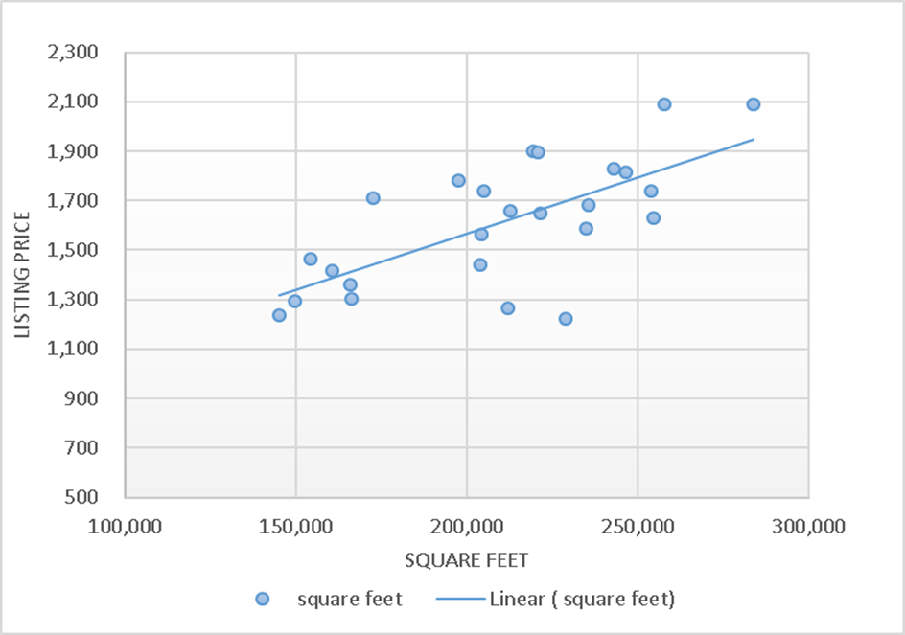
The Pattern
Y which is the assumed variable would be the listing price of the various houses and the X which is the predictor variable should be the Square Feet and doing this, we see an increasing trend, which means, there exist appositive relationship between the two variables (X and Y). The use of the linear graph suites best when it comes to the modeling of the sampled data. If you had a 1,800 square foot house, using the linear regression equation in the graph, the price will be 668.64. Considering the entire number of samples, 17 and 24 are both in the fourth quartile in the listing price and this means the absent of outlier.

Representative Data Sample
Considering the first 30 samples data in the East North Region, the following are the results considering both the listing price and square feet as variables in the sample data.
Within this East North Central Region, Utilizing the data of the 30 Sample units, the following of the were the mean, standard deviation and median the of the listing price
Mean = 210,036
Median = 212,900
Standard Deviation = 38147.17
Within this East North Region, utilizing the data of the 30 sample units, the following were the mean, standard deviation and median of the square feet.
Mean = 1614
Median =1651
Standard Deviation =253.3147

Regression Equation
Based on our graph in the Module Two Assignment, the linear equation was as follows;
Y=0.0045x+660.54

Determine r
Using the excel formula; the R of our different variable is 0.683903. In normal cases, when the R-value is closer to one, then this means there is a strong correlation between the variables and then it far less than one almost to zero, this means that, the variables have a very weak/ low correction. So when considering our two variables, which are the Listing Price and Square Feet, they have a strong correlation. This means that, the more the square feet available, the more the listing price of a similar house and the vice versa is true.

Examine the Slope and Intercepts
Within the context of this problem and basing on the regression equation y=0.0045x+660.54, the slope is 0.0045 and our y intercept is 660.54. These tend to indicate the value of the square feet and the sales price. This means, an increase of the listing price by one dollar (Listing price), is linked to an increase of 0.0045 Square Feet. As I mentioned earlier in the report, this might be because of various factors. I consider concluding on the price of only land to be hard with the only information provided unless more information land is provided.

R-squared Coefficient
R-Square also known as the coefficient of the determinant in relation to this analysis is 0.467. This tends to give a representation of the variance for our listing price variable that is explained by the square feet variable in our analysis. In the context of our analysis, R-squared means, 46.7% of the variance our dependent variable (listing price) tend to be explained by the variance in our square feet variables, which are the independent variables in this analysis.

Conclusions
From the comparison of the sales price/ Listing price and Square Feet, from our selected area of East North Region, there is evident close relationship between the two variables (Square Feet and the listing Price/Sales Price). In consideration of the national statistics provided and those, we found the East North Region, there seems to be possess certain similarities considering their mean, median and standard deviation. These sample data from a selected region in the United States, tend to give a reflection of the sales prices of various houses in the entire country.
Based on our Module 2 graph, the slope was 0.0045. The concept of slope remains to be much significant when it comes to measuring rate of change. Clearly stating the y and x variables tend to be important in clarifying the meaning of slope in relation to the change in y-variables from the one x-variable. The regression equation can be useful when identifying appropriate listing prices because it gives certain relationship from the sample data on how the listing price and square feet vary and thus using the variation, one can easily predict the listing price in different areas. The line graph will be more suitable when to informing range in the square footage.

